**Nova generatsiia (Нова ґенерація; New Generation) (1927-1930)**

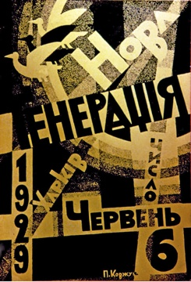

A Ukrainian futurist journal devoted to literature, theory and the visual arts, published in Kharkiv from October 1927 to December 1930 and edited by the futurist poet Mykhail' SEMENKO. *Nova generatsiia* (New Generation) waged a struggle against conservative proletarian writers and promoted the avant-garde. It was the last journal to succumb to Communist Party pressure to disavow its independent artistic program and embrace the emergent Socialist Realist style. The journal covered international artistic trends and had notable figures from Western Europe on its editorial board. When the Russian *Novyi Lef* (New Lef) discontinued publication in December 1928, *Nova generatsiia* invited the formerly rival Russian avant-gardists to contribute. The journal distinguished itself by its typography and layout design in keeping with the modernist aesthetic of De Stijl, the Bauhaus and Constructivism. Several prominent artists (Vadym Meller, Anatoliy Petryts'kyi) contributed to the design of the journal. The Ukrainian painter Kazimir MALEVICH published a series of articles on modern art in *Nova generatsiia* between 1928 and 1930. The poetry and prose in the journal consciously transgressed against traditional notions of “literature.” Destruction of genres was encouraged through their synthesis. On the other hand, strongly plotted popular literature (e.g., detective stories) and hybrid arts of visual poetry, i.e., “poem-painting” (“poezomaliarstvo”) and poezo-film were also prized both for their formalism and rejection of psychological realism.

**References and Further Reading**:

Ilnytzkyj, Oleh S. (2013). “Under Imperial Eyes: Ukrainian Modernist and Avant-Garde Publications.” Editors Peter Brooker, Sascha Bru, Andrew Thacker and Christian Weikop. *Modernist Magazines: A Critical and Cultural History. Volume 3, Part II: Europe 1880-1940.* Oxford: Oxford University Press, 1341-1362.

Ilnytzkyj, Oleh S. (1997). *Ukrainian Futurism: A Historical and Critical Study*. Cambridge/MA: Harvard University Press; Ukrainian Research Institute.

Mudrak, Myroslava M. (1986). *The New Generation and Artistic Modernism in the Ukraine*. Ann Arbor: UMI Research Press.

**Oleh S. Ilnytzkyj, University of Alberta**

**Source of image:**

Scan by author (Oleh S. Ilnytzkyj)